Information of Prof. Alfonso H.W. Ngan (颜庆云教授)

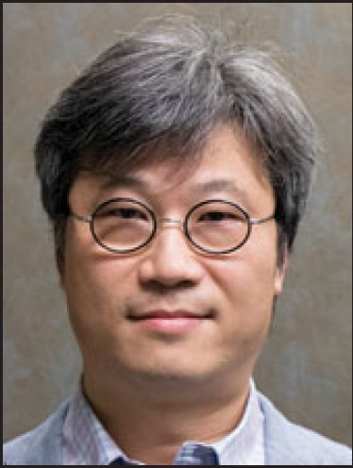
Professor Alfonso H.W. Ngan is currently Kingboard Professor in Materials Engineering, Chair Professor of Materials Science and Engineering, as well as Head of Department of Mechanical Engineering, at the University of Hong Kong. He obtained his BSc(Eng) degree from the University of Hong Kong in 1989, and PhD from the University of Birmingham in the U.K. in 1992. After a year of postdoctoral training at Oxford University, he joined HKU in 1993, and was promoted through the ranks to Chair Professorship in 2011.
Professor Ngan is a leading authority in the microstructural basis of properties of engineering materials, in particular, crystalline defects and their modeling, and nanomechanics including applications to biological systems. He has published over 200 ISI papers, and co-authored two books. His main contributions include a method, the so-called “Feng-Ngan equation”, for correcting viscoelastic effects in nanoindentation measurements of soft materials, which has been used by peer researchers in their work as reported in more than 100 ISI publications by now. His research-related honours include the prestigious Rosenhain Medal and Prize from the Institute of Materials, Minerals and Mining, U.K., in 2007 – he is the only non-British national so far to have received this award since its establishment in 1951. He was also awarded a higher doctorate (DSc) from his alma mater the University of Birmingham in 2008, the Croucher Senior Research Fellowship in 2009, and in 2014 he was elected to the Hong Kong Academy of Engineering Sciences. He is a well sought-after journal reviewer, winning the Outstanding Reviewer Award of Scripta Materialia five times, in 2006, 2008, 2011, 2015 and 2016. He has organized a number of key conferences, including Dislocations 2008 and Gordon Research Conference on Nanomechanical Interfaces in 2013, both held in Hong Kong. He is serving on the Gordon Research Conference Board for Hong Kong Conferences. He served as one of five Meeting Chairs in the Materials Research Society 2017 Spring Meeting held in Phoenix, USA, in April 2017.
For feedback from a graduate of Prof. Ngan, please read:
http://epaper.southcn.com/nfdaily/html/2016-09/09/content_7581330.htm
Other media coverage of Prof. Ngan:
https://www.cambridge.org/core/services/aop-cambridge-core/content/view/S0883769415003243
https://www.youtube.com/watch?v=RYypGmLFjQM&feature=youtu.be

